University of Regina
Department of Computer Science
Winter 2019

CS 824 - Information Retrieval

Assignment 4

Submitted to Dr. Yiyu Yao

By

Chao Zhang

Regina, April 6, 2019
1. Derive the results of probabilistic models of IR.
a) Probabilistic retrieval model
b) Probabilistic indexing model
c) A unified model.

- In the probabilistic retrieval model, a document is represented by a min-term m_{d} defined by 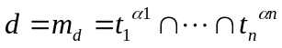. By substituting it into the log-odds transformation of the precision-oriented measure, we obtain:
.
Suppose we use the following approximations:
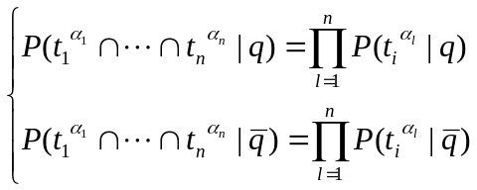
By substituting these values into the above formula, we can obtain:
.
Let 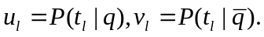 Then the probabilities can be written as:
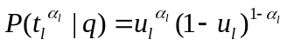, 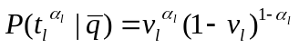.
By combing all of these value, we can obtain the probability retrieval model:

- In the conventional probabilistic indexing model, a query is represented by a single atomic concept m_{q}, namely:
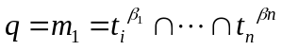, where 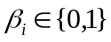and 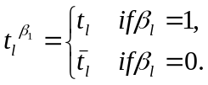
That is, an index term is not negated if it appears in the text of the query otherwise, it is negated. For the recall-oriented measure, we obtain:
By substituting the query into the recall-oriented measure we can obtain:
.
From the probabilistic-like definition of intersection, we know:
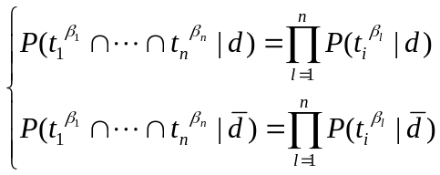
By substituting the probabilistic-like definition of intersection into what we obtain above, then we can get:
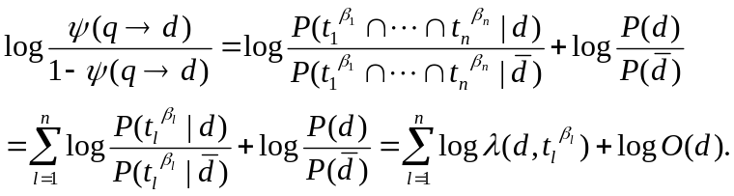
Thus, the indexer can either provide 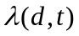 and 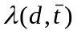, or the probabilities 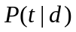and 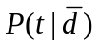. Let 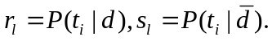Then the probability can be written as: 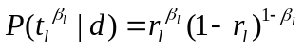, 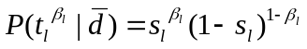.
By combing all of these value, we can obtain the probability indexing model:

- According to the Bayes decision procedure, a document described by x is judged to be relevant to a query described by y if 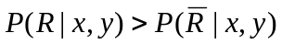. then we can construct a discriminant function: 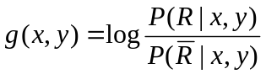and the function can be rewritten as 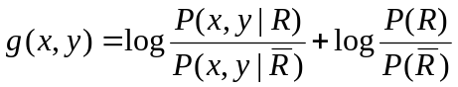where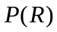and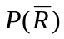are the priori probabilities. In the proposed model, we make the following independence assumptions: 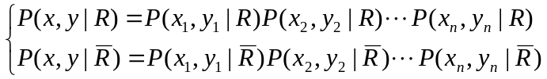. It means that the cooccurrence of each index term in the document-query pairs with respect to  and 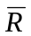 is assumed to be independent of other terms. These assumptions can be considered as the generalization of the independence approximations. Then they can be 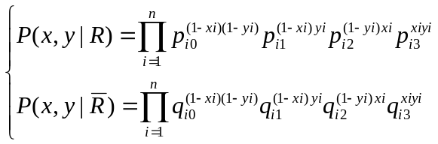. By substituting 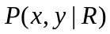and 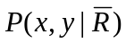, we can obtain:
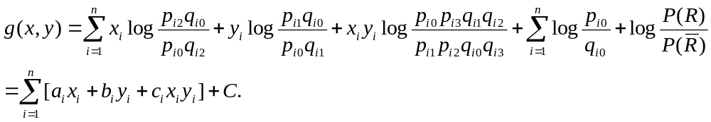
where 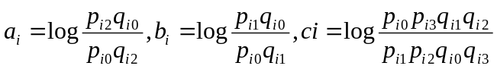and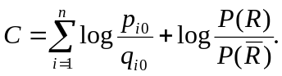
Considering the problem of estimating the probabilities, the parameters can be computed from the formulas:
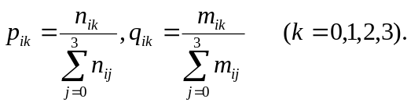

- Discuss the main ideas of probabilistic inference models.

Based on probabilistic inference models, we firstly discuss the Bayesian inference
which is a method of statistical inference for updating the probability for a hypothesis as more evidence or information becomes available. The computation for Bayesian inference is 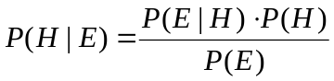where H stands for hypothesis, P(H) is prior probability, E is the evidence, P(H|E) is the posterior probability, P(E|H) is the probability of H given E and P(E) is the marginal likelihood. For different values of H, only the factors P(H) and P(E|H) affect the value of P(H|E). So Baye’s rule can be written as follows: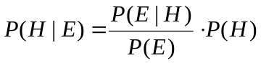where the factor 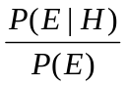can be interpreted as the impact of E on the probability of H. Pr(H) is belief before seeing evidence and Pr(H|E) is belief after seeing the evidence. In probabilities inference models, binary vector space can be classified into three cases: 1. precision-based: 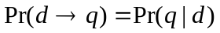; 2. recall-based: 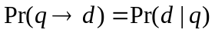; 3. balanced: 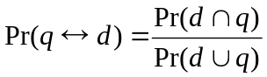. What we want to know is Q-T-D and what we know is query and indexing. For vector representation, it is 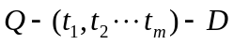. With respect to Bayesian inference, what we want to know is 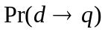. Based on document representation 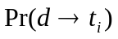, for t_{j} in T, query representation is 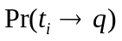. We view each t_{j} as one piece of evidence and T is a pool of many pieces of evidence. Based on t_{j}, we can get 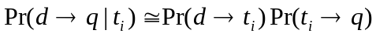. Assume that t_{j} are independent or non-overlap which is 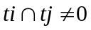. Based on T, 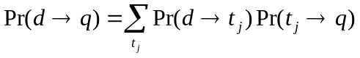where
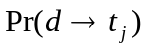 is document and 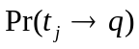 is query.

